CS 3516

Computer Networks

Take-Home Final Examination

June 29, 2017

Your Solutions Are Due on Our Class Website No Later Than Midnight EDT / EST on Saturday, July 1, 2017

Open Book

Open Notes

Show Your Work!

Name:__________________________________________________________________

There are eleven questions in this examination, and most problems are weighted equally at ten points, except for problem 1 which is weighted at 10 points. You must complete all eleven questions correctly to obtain full credit for the examination.

- Consider the network of queues shown in Figure 1 below. Assume that all arrival and service processes have exponential distributions, and that this system can be modeled as a network of independent M/M/1 queuing systems using Jackson's Theorem.

Compute the mean times that a packet spends in each segment of this system, namely T₁,
T₂, T₃ and T4, as well as the average time that a packet spends in the entire system T,
given the arrival rates, service rates and traffic partitioning probabilities given in this figure.
(10 points)

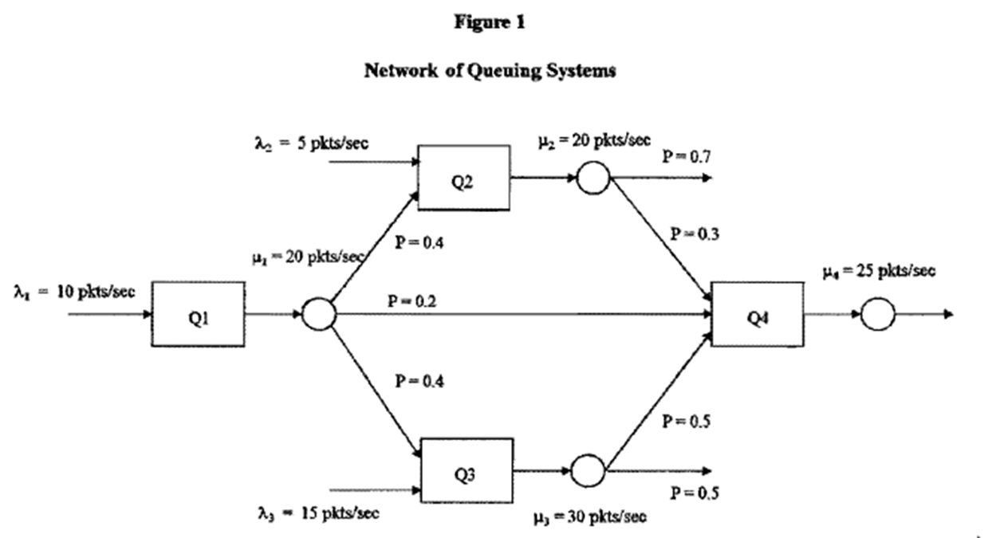

- Polynomial codes are typically used for the detection of transmission errors in computer networks. Consider a polynomial code which is based on the CRC-12 generator polynomial G(X) = X¹² + X¹¹ + X³ + X² + X + 1 .

- Given the message polynomial M(X) = X¹⁵ + X¹² + X¹¹ + X¹⁰ + X⁷ + X⁵ + X + 1, compute the corresponding valid code polynomial T(X). (5 points)

- What error patterns can be detected by this generator polynomial, and what fraction of errors can be detected by this generator polynomial? (4 points)

3. The distance from the earth to a distant planet is approximately 9 x 10¹⁰ meters. Assume that a stop-and-wait protocol is used for frame transmission on a 64 Mbps point-to-point link, given that the link is noise-less (error-free), the frame size is 32 Kbytes, the speed of light is 3 x 10⁸ meters/second, and the header size and processing delays at the sender and received are negligible.

- What is the channel utilization of the stop-and-wait protocol? (5 points)

- Assume that a sliding window protocol is used instead of the stop-and-wait protocol. What is the optimum window size for the sender that will achieve maximum utilization of the link? (4 points)

- Consider the Go-Back-N and Selective Repeat sliding window protocols given a noise-less (error-free) channel. The frame size is 1000 bytes, headers are short and ACKs are always piggybacked. What is the optimal window size that will achieve maximum channel utilization for these protocols over a 64 kbps satellite channel with a round-trip delay time of 0.54 seconds, and how many sequence bits are required by each protocol to achieve this utilization? (9 points)

- In the network shown below, frames are generated at Node A and sent to Node C through Node B. Nodes B and C acknowledge each data frame immediately upon receipt to Nodes A and B, respectively. The channel data rate between Nodes A and B is 256 kbps and the data rate between nodes B and C is 1 Mbps. The lines between each pair of nodes are full-duplex, and the propagation delay for each line is 10 μsec/mile. All data frames are 1000 bits long and ACKs are separate frames of negligible length. A sliding window protocol with a window size of W is used between Nodes A and B, and a stop-and-wait protocol is used between Nodes B and C. All lines are error-free and no frames can be lost.

What is the maximum window size W_{max} that can be used between nodes A and B without flooding the buffers of node B? (9 points)

Hint: The buffers of node B will not be flooded if the average number of frames entering and leaving Node B are equal over a long time interval (at steady-state).
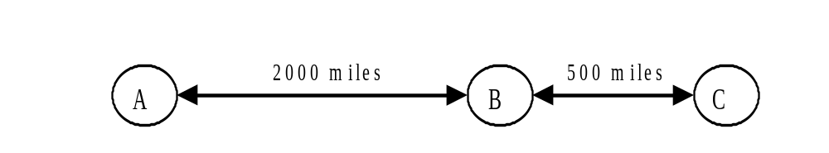

6. Ten thousand airline reservation stations are competing for the use of a single slotted ALOHA channel. The average station makes 30 requests/hour and a slot is 125 μsec in duration. What is the approximate total channel load and resulting throughput?
(9 points)

7. Consider a CSMA/CD LAN with N independent stations. The probability that a station will transmit on an interference interval when given the opportunity is p.

- Derive a formula for the probability P(A) that one and only one station will transmit on an interference interval. (5 points)

- Compute the value of the probability p which maximizes the value of P(A), thereby achieving maximum throughput for this LAN. (4 points)

8. Consider designing a 2 km-long, 1 Gbps LAN which uses CSMA/CD and has a propagation speed of 200 m/μsec. What is the minimum frame size and the optimal channel efficiency that can be achieved using this frame size? (9 points)

9. Assume that the bridges shown below are transparent bridges, and that all stations have sent and received frames to/from all other stations. Construct the bridge tables for all three bridges. (9 points)
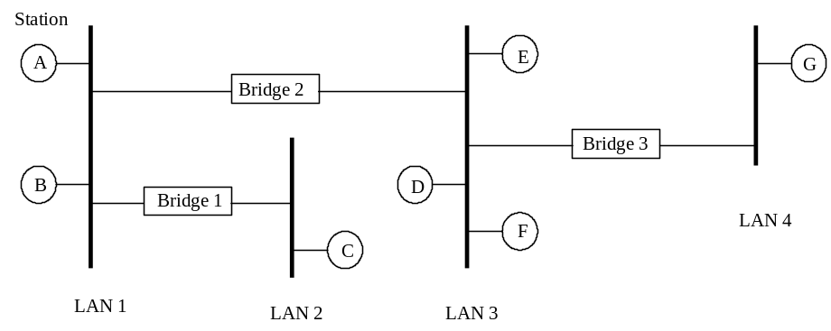

10. Consider the network shown below. The numbers shown for each link are the delays between nearest neighbors for that link. Apply Dijkstra’s algorithm to this network starting at node 1, and label each node with the shortest path route to node 1 using the same label techniques shown in Figure 5-7 in Tanenbaum. (9 points)

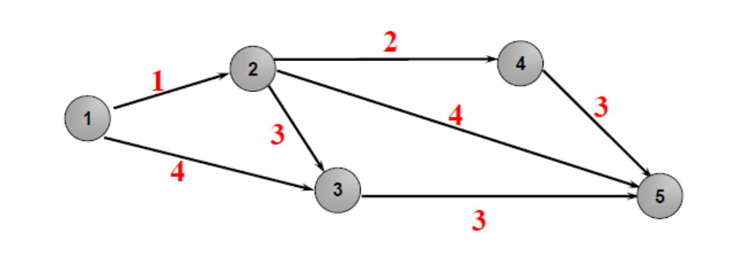
11. Assume that that network shown below from Figure 5-7 in Tanenbaum uses link state routing. The numbers shown for each link are the delays between nearest neighbors for that link. Construct the link state packets for all eight routers. (9 points)

